**Cross Join and Self Join**

Cross Join

-- The SQL CROSS JOIN produces a result set which is the number of rows in the first table multiplied by the number of rows in the second table if no WHERE clause is used along with CROSS JOIN. This kind of result is called as Cartesian Product.

-- If WHERE clause is used with CROSS JOIN, it functions like an INNER JOIN.

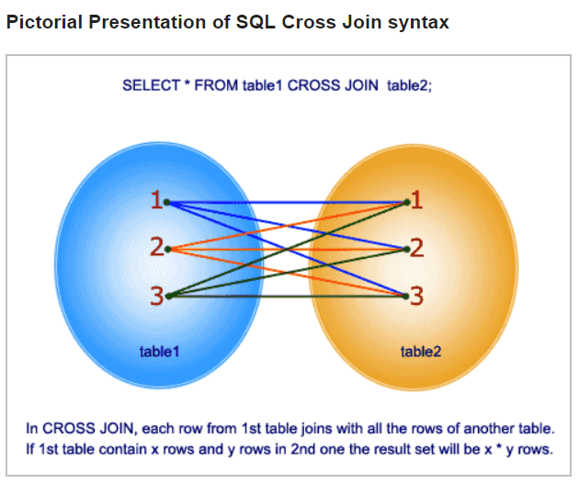

-- An alternative way of achieving the same result is to use column names separated by commas after SELECT and mentioning the table names involved, after a FROM clause.

SELECT *

FROM dev_schema.employee CROSS JOIN dev_schema.department;

Self Join

-- **Self Join**, as its name suggests, is a type of join that combines the records of a table with itself.

-- SQL self join is used to join or compare a table to itself. SQL self joins are used to compare values of a column with values of another column in the same table.

-------------- TBD ---------------